

lqe'jg ljZjljBfno af6 ;DaGwg k|fKt lxdlzv/ ax'd'vL SofDk; e]/LUf+uf –!!,/fd3f6, ;'v{]tdf lj=P8 / lj=lj=P; k|yd jif{df gofF egf{ v'n]sf] Joxf]/f ;xif{ hfgsf/L u/fO{G5 .

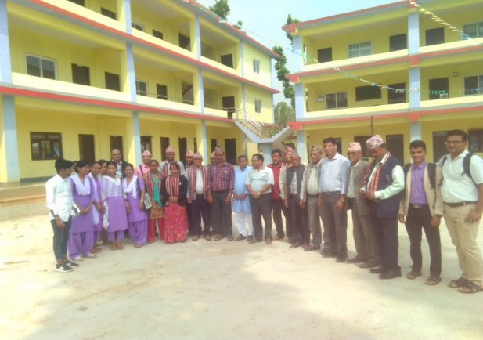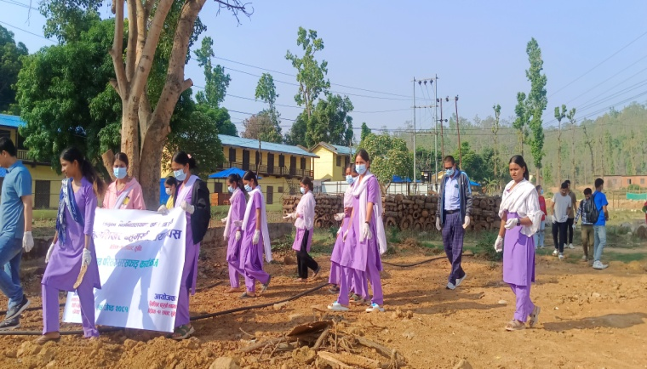k9fO{ x'g] ljifox? M

